package assistedprojectjava;

public class Throw {

public static void main(String[] args) {

int a=25,b=1,rs;

try

{

if(b==1)

throw(new ArithmeticException("Can't divide by zero."));

else

{

rs = a / b;

System.***out***.print("\n\tThe result is : " + rs);

}

}

catch(ArithmeticException Ex)

{

System.***out***.print("\n\tError : " + Ex.getMessage());

}

System.***out***.print("\n\tEnd of program.");

// **TODO** Auto-generated method stub

}

}

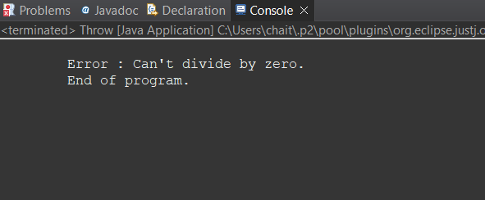

package assistedprojectjava;

public class Throws {

void Division() throws ArithmeticException

{

int a=45,b=0,rs;

rs = a / b;

System.***out***.print("\n\tThe result is : " + rs);

}

public static void main(String[] args) {

Throws T = new Throws();

try

{

T.Division();

}

catch(ArithmeticException Ex)

{

System.***out***.print("\n\tError : " + Ex.getMessage());

}

System.***out***.print("\n\tEnd of program.");

// **TODO** Auto-generated method stub

}

}

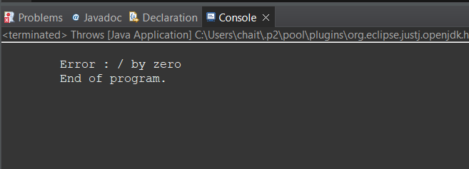

package assistedprojectjava;

public class FinallyBlock {

public static void main(String[] args) {

int a=25,b=0,rs=0;

try

{

rs = a / b;

}

catch(ArithmeticException Ex)

{

System.***out***.print("\n\tError : " + Ex.getMessage());

}

finally

{

System.***out***.print("\n\tThe result is : " + rs);

}

// **TODO** Auto-generated method stub

}

}

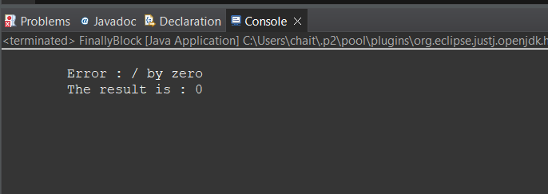

package assistedprojectjava;

class MyException extends Exception

{

public MyException(String s)

{

super(s);

}

}

public class main {

public static void main(String[] args) {

try

{

throw new MyException("temp");

}

catch (MyException ex)

{

System.***out***.println("Caught");

System.***out***.println(ex.getMessage());

}

// **TODO** Auto-generated method stub

}

}

